Jonathan Rile
Partner: Alexander Botten
701085173
CpE 311 – Wednesday 5-7:50
3/5/14

Lab 8: Switch Debouncing

Introduction
The purpose of this short lab was to fix the issue that we discovered in Lab 2: debouncing. For this lab, we were to capture the bouncing, and implement a solution in our software to stop it from happening.

Exercise 1: Toggle Switch

Experiment
For this experiment, all we had to do is connect a single toggle switch to an input port of the Octagon 6040 as we’ve done in the past.

Results
The circuit was successfully created and verified.

Exercise 2: Bouncing

Experiment
The goal of this experiment is to create a program that will capture the input values as we receive them, so that we can visually see the bouncing occur. To do this, we created a storage variable that holds 300 input values, and put every input we saw into that. We then printed it out after we had efficiently stored the input.
Assume cs:code, ds:data, ss:stack

data segment
message db 501 dup(?)
data ends

stack segment
dw 100 dup(?)
stacktop:
stack ends

code segment
begin:
Mov ax,data
Mov ds,ax
Mov ax,stack
Mov ss,ax
Mov sp, offset stacktop

MOV DX,143H ;specify control register
MOV AL,02H ;direction mode
OUT DX,AL ;send to dx

MOV DX,140H ;specify port A
MOV AL,00H ;0000 0000, all outputs
OUT DX,AL

MOV DX,143H ;specify control register
MOV AL,03H ;operation mode
OUT DX,AL

MOV DX,140H ;port A
mov cx, 500
mov si, offset message

buttonpress:
in al, dx
and al, 01h
cmp al, 0
jne buttonpress

buttonrelease:
in al, dx
and al, 01h
cmp al, 1
jne buttonrelease

loop1:
IN al,DX ;get input
mov [si], al
inc si
loop loop1
mov al, "$"
mov [si], al
mov si, offset message
call print

end_prog:
mov ah, 4ch
int 21h

print:
push ax
push dx

mov ah, 2
abc: ;loop title to display entire message
mov dl, [si]
cmp dl, "$"
je end_loop
AND dl, 01H ;mask input
add dl, 30H
int 21h
inc si
jmp abc

end_loop:
mov dl, 0dh
int 21h
mov dl, 0ah
int 21h
pop dx
pop ax
ret

code ends
end begin

Results
The program successfully compiled and worked as expected.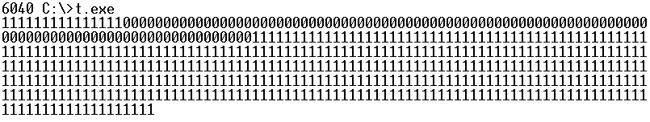

Exercise 3: Software Debounce

Experiment
In this exercise, this is where we were to actually implement a solution to stop the bouncing from occurring. What the solution does is waits a period of time before receiving new input.
Assume cs:code, ds:data, ss:stack

data segment
message db 501 dup(?)
data ends

stack segment
dw 100 dup(?)
stacktop:
stack ends

code segment
begin:
Mov ax,data
Mov ds,ax
Mov ax,stack
Mov ss,ax
Mov sp, offset stacktop

MOV DX,143H ;specify control register
MOV AL,02H ;direction mode
OUT DX,AL ;send to dx

MOV DX,140H ;specify port A
MOV AL,00H ;0000 0000, all outputs
OUT DX,AL

MOV DX,143H ;specify control register
MOV AL,03H ;operation mode
OUT DX,AL

MOV DX,140H ;port A
mov cx, 500
mov si, offset message

buttonpress:
in al, dx
and al, 01h
cmp al, 0
jne buttonpress

buttonrelease:
in al, dx
and al, 01h
cmp al, 1
jne buttonrelease
call delay ; debouncing
loop1:
IN al,DX ;get input
mov [si], al
inc si
loop loop1
mov al, "$"
mov [si], al
mov si, offset message
call print

end_prog:
mov ah, 4ch
int 21h

print:
push ax
push dx

mov ah, 2
abc: ;loop title to display entire message
mov dl, [si]
cmp dl, "$"
je end_loop
AND dl, 01H ;mask input
add dl, 30H
int 21h
inc si
jmp abc

end_loop:
mov dl, 0dh
int 21h
mov dl, 0ah
int 21h
pop dx
pop ax
ret

delay:
push ax
push dx
push cx

MOV BX,0FH
outer:
MOV CX,0FH ; (4 cycles)

wasteTime: ; loop 1 3 + 17 = 20
NOP ; no operation (3 cycles)
loop wasteTime ; loop 2 (17 cycles)
; 20 * CX

DEC BX ; (2 cycles)
JNZ wasteTime ; (16 cycles)

pop cx
POP DX
POP AX
RET

code ends
end begin

Results/Questions
Our program successfully compiled and worked as expected.
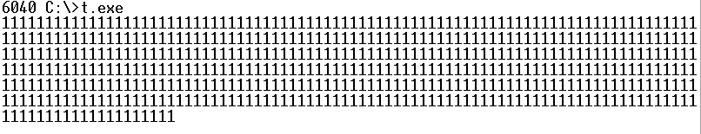
- Explain the advantages and disadvantages to this type of solution:
It’s main advantage is that it is very simple to implement. There are some downsides though, such as if the user wants to press the button faster than the software “cool-down” period allows for them to.
- What happens if the delay is too long?
If the delay is too long, the user may be pressing the button and the software is not recognizing that.
- What happens if the delay is too short?
If the delay is too short, the program may be picking up some of the bouncing that we saw in Exercise 2.

Conclusion
I found this lab to be very helpful, since in Lab 2 we discovered what bouncing was but we never actually implemented a solution. Now that we know of a good way to solve this problem, it will make using input in future assembly programs much easier.

